Project 1

**Title:** AWS Usage Reporting Script

**What is the project about and why is it needed?**

This project addresses a fundamental daily task for DevOps engineers. It involves monitoring the usage of AWS resources (such as EC2, S3, etc.) on a daily basis at a specific time and reporting the findings to our manager. This monitoring and reporting process is essential for ensuring optimal resource utilisation, cost management, and proactive issue resolution.

**What are the steps to implement the project?**

Prerequisites : Shell Scripting , Aws Cli.

Environment : Aws Ubuntu machine

Step 1: ssh into the Aws Ec2 machine

> ssh -i /home/dell/AWS_credentials/Test_server_1_key_pair.pem ubuntu@ip_address

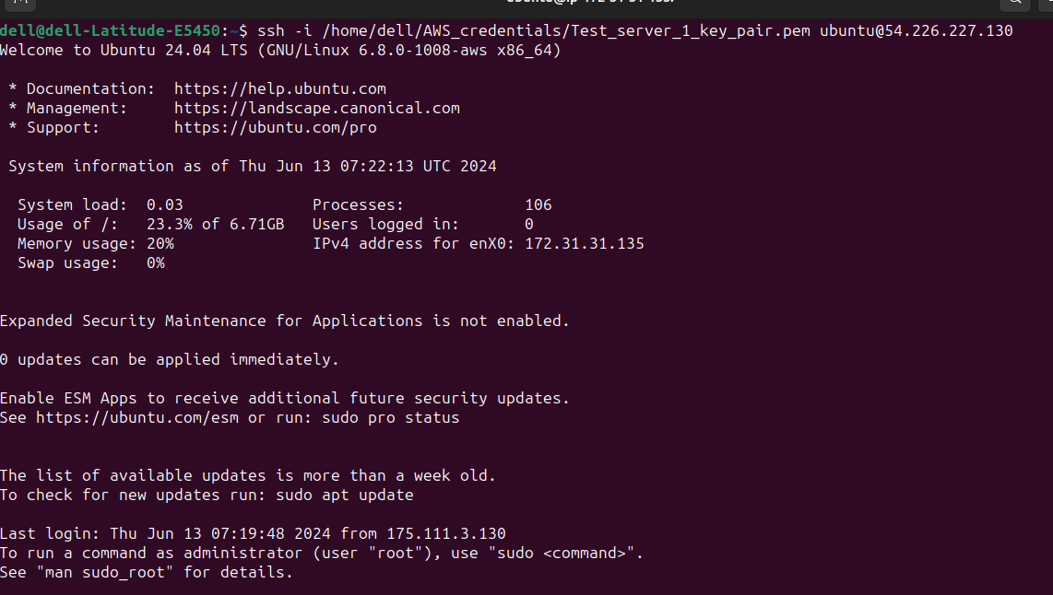

Step 2: Install Aws cli and Aws configure

> sudo apt update

> sudo apt install unzip curl -y

> curl "https://awscli.amazonaws.com/awscli-exe-linux-x86_64.zip" -o "awscliv2.zip"

> unzip awscliv2.zip

> sudo ./aws/install

> aws --version



AWS configure : To communicate with AWS we need to configure our credentials.

> aws configure

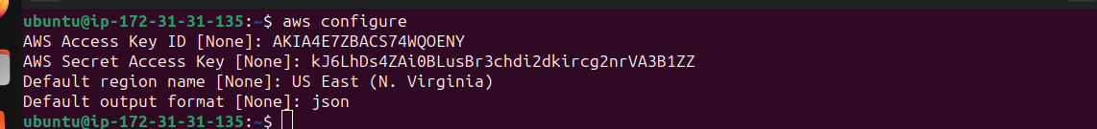

Step 3: Write , execute and run script

**Script**

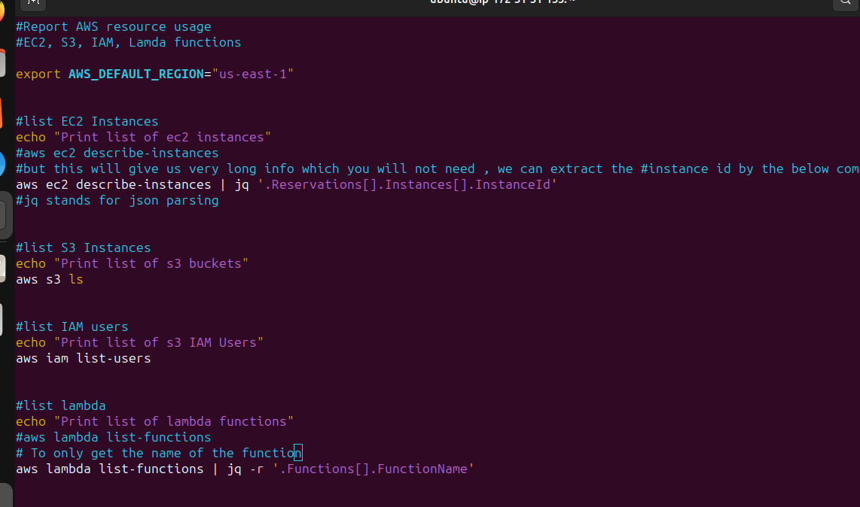

Result after execution

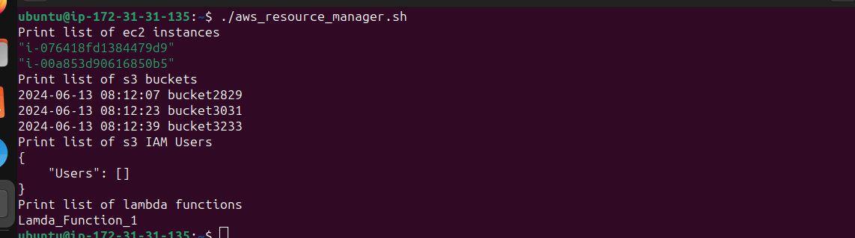

Step 4 : Add to the cron job to execute at 7 pm everyday.

> crontab -e

